Polymorphism is divided into two types.

1. Compile time polymorphism achieved by method overloading .
2. Runtime time polymorphism (or ) true polymorphism achieved by method overriding.

Advantages of runtime polymorphism :

1. Flexibility
2. Code size reduces

Eg: Tight_And_Loose_Coupling

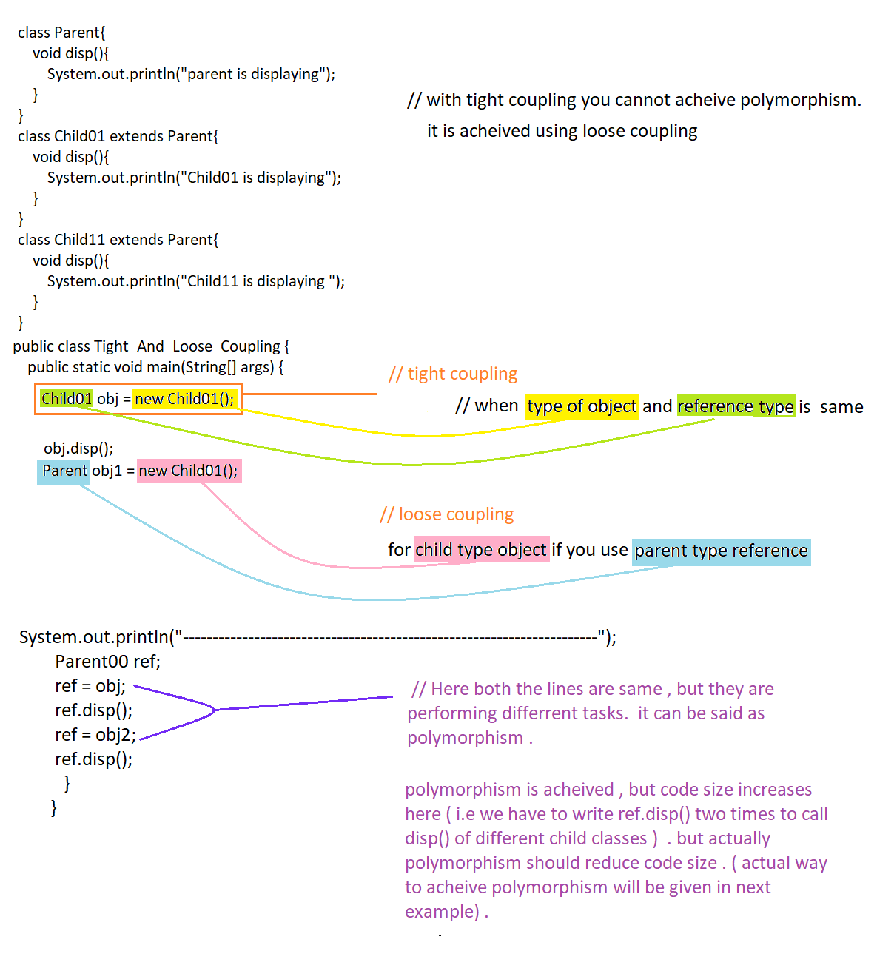

Eg: Loose_Coupling_Polymorphism

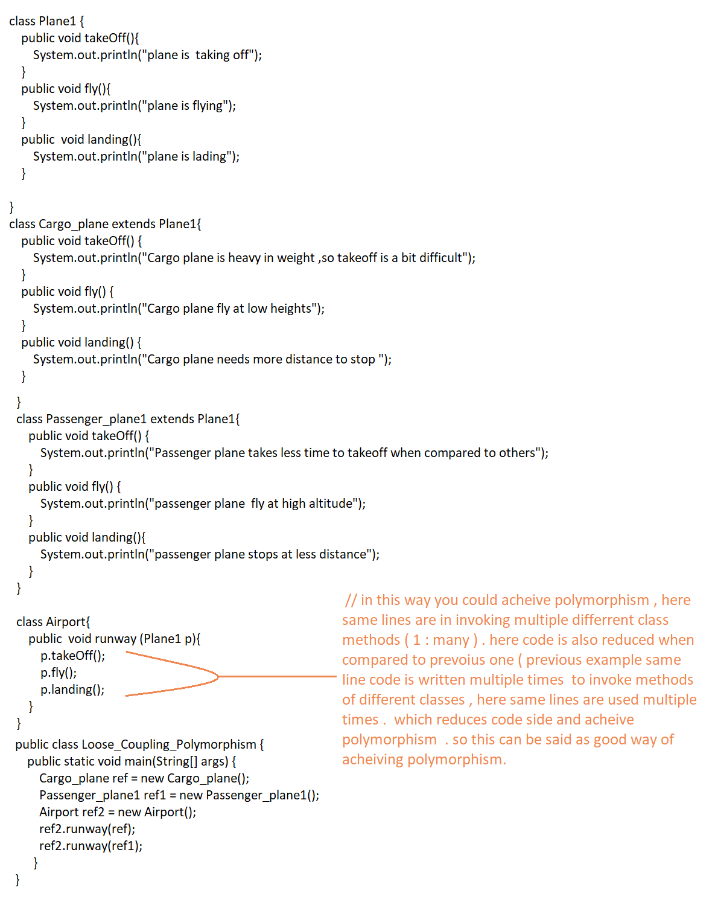

Eg: Downcasting_Upcasting.

